**Climate Data Analysis and Prediction Using Machine Learning**

**About dataset**: This project focuses on analyzing climate data for Jashore (2019-2021) using machine learning techniques. The objectives include predicting maximum temperature (Temp_MAX), uncovering climate patterns through clustering, and assessing the influence of various factors using regression models. The analysis provides valuable insights into the region's climate variability and trends.

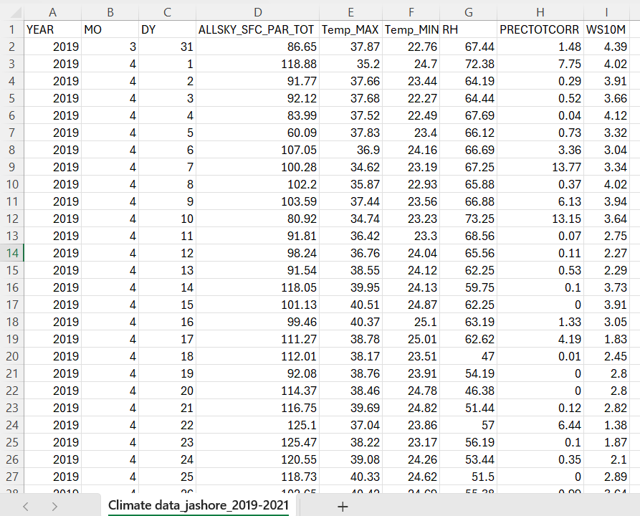

Figure 1 Climatic Dataset

**Linear Regression** was chosen for this dataset because of its simplicity and effectiveness in modeling the relationship between continuous variables. Given the dataset's focus on predicting Temp_MAX (maximum temperature) using features such as Temp_MIN (minimum temperature) and RH (relative humidity), Linear Regression is well-suited to determine and quantify the linear relationships between these variables. Additionally, it provides interpretable results, which are crucial for understanding how changes in one factor impact the target variable.

**Objectives**

* Predict Temp_MAX using historical data.
* Classify climate patterns using clustering.
* Evaluate the influence of temperature, humidity, and seasonal changes through regression models.

**3. Data Description**

The dataset contains climate records from 2019 to 2021 for Jashore, with the following columns:

* **YEAR**: Year of observation
* **MO**: Month
* **Temp_MAX**: Maximum temperature
* **Temp_MIN**: Minimum temperature
* **RH**: Relative humidity

**Methodology:**

**Data Preprocessing**

* Handled missing data and ensured feature consistency.
* Split the dataset into training and testing sets (80:20 ratio).

**Linear Regression**

* Used Temp_MIN and RH to predict Temp_MAX.
* Evaluated the model using Mean Squared Error (MSE) and R² Score.

**Clustering**

* Determined optimal clusters using the elbow method.
* Applied KMeans clustering with 3 clusters based on Temp_MAX, Temp_MIN, and RH.

**CODE:**

import pandas as pd  
from sklearn.model_selection import train_test_split  
from sklearn.linear_model import LinearRegression  
from sklearn.metrics import mean_squared_error, r2_score  
import matplotlib.pyplot as plt  
  
*# Load the dataset*file_path = r"E:\Machine learning\Ml class_cse\Climate data_jashore_2019-2021.csv"  
climate_data = pd.read_csv(file_path)  
  
*# Selecting relevant columns and ensuring no missing values*data = climate_data[['Temp_MAX', 'Temp_MIN', 'RH']].dropna()  
  
*# Splitting the data into features and target*X = data[['Temp_MIN', 'RH']]  
y = data['Temp_MAX']  
  
*# Splitting the data into training and testing sets*X_train, X_test, y_train, y_test = train_test_split(X, y, test_size=0.2, random_state=42)  
  
*# Creating the Linear Regression model*linear_model = LinearRegression()  
  
*# Fitting the model*linear_model.fit(X_train, y_train)  
  
*# Predicting on the test set*y_pred = linear_model.predict(X_test)  
  
*# Calculating performance metrics*mse = mean_squared_error(y_test, y_pred)  
r2 = r2_score(y_test, y_pred)  
  
*# Printing the metrics*print(f"Linear Regression MSE: {mse:.4f}")  
print(f"Linear Regression R2: {r2:.4f}")  
  
*# Visualizing the results: Predicted vs. Actual*plt.figure(figsize=(8, 6))  
plt.scatter(y_test, y_pred, color='Green', alpha=0.7, edgecolor='k', label='Predicted vs. Actual')  
plt.plot([y_test.min(), y_test.max()], [y_test.min(), y_test.max()], 'r--', linewidth=2, label='Perfect Fit')  
plt.title('Linear Regression: Actual vs. Predicted Temp_MAX')  
plt.xlabel('Actual Temp_MAX')  
plt.ylabel('Predicted Temp_MAX')  
plt.legend()  
plt.grid(True)  
plt.show()

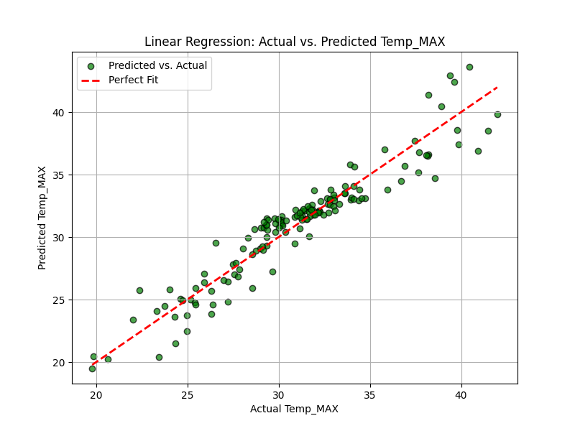

**Figure 2 linear Regression**

**Results and Discussion**

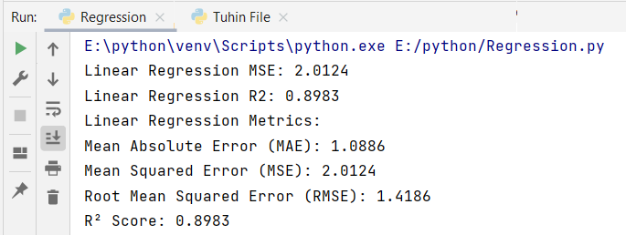

Figure 3 Output

Linear Regression Results

Linear Regression MSE: 2.0124

Linear Regression R2: 0.8983

**Clustering**

* Determined optimal clusters using the elbow method.
* Applied KMeans clustering with 3 clusters based on Temp_MAX, Temp_MIN, and RH.

CODE:

import pandas as pd  
from sklearn.cluster import KMeans  
from sklearn.metrics import silhouette_score  
import matplotlib.pyplot as plt  
  
*# Load the dataset*file_path = r"E:\Machine learning\Ml class_cse\Climate data_jashore_2019-2021.csv"  
climate_data = pd.read_csv(file_path)  
  
*# Selecting features for clustering and ensuring no missing values*clustering_features = climate_data[['Temp_MAX', 'Temp_MIN', 'RH']].dropna()  
  
*# Determining the optimal number of clusters using the elbow method*inertia = []  
for k in range(1, 11):  
 kmeans = KMeans(n_clusters=k, random_state=42)  
 kmeans.fit(clustering_features)  
 inertia.append(kmeans.inertia_)  
  
*# Plotting the elbow curve*plt.figure(figsize=(8, 5))  
plt.plot(range(1, 11), inertia, marker='o', linestyle='--')  
plt.title('Elbow Method for Optimal Clusters')  
plt.xlabel('Number of Clusters')  
plt.ylabel('Inertia')  
plt.grid(True)  
plt.show()  
  
*# Applying KMeans with an optimal number of clusters (e.g., 3)*optimal_clusters = 3  
kmeans_model = KMeans(n_clusters=optimal_clusters, random_state=42)  
cluster_labels = kmeans_model.fit_predict(clustering_features)  
  
*# Adding cluster labels to the data*climate_data['Cluster'] = cluster_labels  
  
*# Displaying the first few rows with cluster labels*print(climate_data[['Temp_MAX', 'Temp_MIN', 'RH', 'Cluster']].head())  
  
*# Calculating the silhouette score as the accuracy metric*silhouette_avg = silhouette_score(clustering_features, cluster_labels)  
print(f"Silhouette Score for {optimal_clusters} clusters: {silhouette_avg:.4f}")  
  
*# Visualizing the clusters*plt.figure(figsize=(10, 6))  
for cluster in range(optimal_clusters):  
 cluster_data = clustering_features[cluster_labels == cluster]  
 plt.scatter(cluster_data['Temp_MIN'], cluster_data['Temp_MAX'], label=f'Cluster {cluster}', alpha=0.7)  
  
*# Marking centroids*centroids = kmeans_model.cluster_centers_  
plt.scatter(centroids[:, 1], centroids[:, 0], c='black', marker='X', s=200, label='Centroids')  
  
plt.title('KMeans Clustering: Temp_MIN vs Temp_MAX')  
plt.xlabel('Temp_MIN')  
plt.ylabel('Temp_MAX')  
plt.legend()  
plt.grid(True)  
plt.show()

Figure 4 Elbow method

Figure 5 Clustering

**Clustering Results**

* Optimal number of clusters: 3
* Clusters represented distinct climate patterns based on temperature and humidity.

**Conclusion**

The project demonstrated the effectiveness of machine learning in analyzing climate data. Linear regression and clustering highlighted temperature trends and patterns, while multiple regression provided deeper insights into seasonal variations. Future work could explore advanced models and larger datasets for enhanced accuracy.